18.79: For 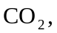the contribution to 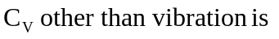

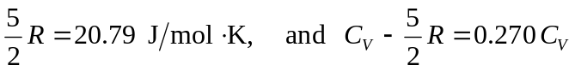
For both SO₂ and H₂S, the contribution to C_{V} other than vibration is

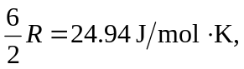
and the respective fractions of 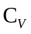are 0.25 and 0.039.

